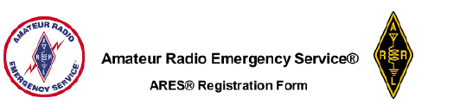

Name:
Call Sign:
Mailing Address:
City, State, ZIP code:
e-mail addresses:
Home phone number:
Work phone Number:
Cell phone number:
License Class:
ICS Courses

Check bands and modes that you can operate:
MODE | HF | 60m | 6m | 222MHz | 440MHz | Others
SSB
CW
FM
DATA
PACKET
D-STAR
Other modes
Specify below
Mobile
Go Kit

Can your home station be operated without commercial power: Yes[ ] No[ ]

Signature______________________________________________ Date__________________

